BIRDS-5

Wire Strength Test Report

Revision History

|  |  |  |  |
| --- | --- | --- | --- |
| Version | Date | Writer | Annotations |
| 1 | 2021.12.09 | XXX | Initial Release |
| 1.1 | 2022.01.31 | Edgar Mujuni | Test Results |
| 1.2 | 2022.03.09 | Edgar Mujuni | Made changes |
|  |  |  |  |
|  |  |  |  |

Contents

**1.** **Purpose** 1

**2.** **Applicable Document** 1

**3.** **Test Method** 2

**3.1** **Strength Test for Flight Equivalent Wire (ultimate load)** 2

**3.2** **Proof Test for Flight Wire** 4

**4** **Test Results** 6

**4.1** **Strength test** 6

**4.2** **Proof test** 6

**5** **Conclusion** 8

# **Purpose**

This document summarizes the plan of wire strength and proof test for BIRDS-5 which will be deployed from JEM Small Satellites Orbital Deployer (J-SSOD).

# **Applicable Document**

1. JX-ESPC-101132-D JEM Payload Accommodation Handbook-Vol.8-

Small Satellite Deployment Interface Control Document

**Section 2.1. Mechanical Interfaces**

2.1.8. Structural Strength

1. A satellite shall have a sufficient structural strength with a necessary margin of safety through the ground operation, testing, ground handling, launch and on-orbit operations. Launch environment is defined in the section 2.4.1.
2. Each rail shall have a sufficient structural strength with considering that the rail is subject to compression force at 46.6 N due to a preload from the Backplate and main spring of J-SSOD.

**Section 4.2. Safety Assessment**

4.2.2.2. Unique Hazards

1. Deployable Structure

Option 2 (When not satisfying the requirement described in 2.1.4. (6)):

Even in the event of an inadvertent deployment, a unique hazard report will be required in consideration of hazards of inappropriate deployment of the satellite due to stick inside the J-SSOD. As safety design and verification methods for this hazard, one of the following can be chosen.

1. 2 Fault tolerance design

If deployable components have two failure tolerance based on the Section 1.3.1 “Applicable Document” (1) JSX-2010026 during the period from launch to deployment by the J-SSOD, it has sufficient safety control against a hazard of inadvertent deployment. In this case, the control is required for the restraint wire of the deployable components based on the applicable document (12), JMX-2012694 “Structure Verification and Fracture Control Plan for JAXA Selected Small Satellite Released from J-SSOD”.

1. JMX-2011303E Structure Verification and Fracture Control Plan

for JAXA Selected Small Satellite Released from J-SSOD

**Section 6 Fracture Control Plan**

(6) Deployable Structure

**Table 6-4 Control for wire mechanism of deployment structure**

| No. | Requirement |
| --- | --- |
| 1 | More than two wires are required for one constraining object |
| 2 | Test to withstand the expected maximum load by only one wire as proof test. Refer to section 7.2 |
| 3 | Inspect not to exist appearance abnormality after the proof test. Refer to 7.2 |
| 4 | Add cautions when using in the assembly procedure. |
| 5 | If contact between wire and the other structure is inevitable, the contact surface of the structure shall be rounded adequately. |
| 6 | If wire mechanism has a knot, the looseness shall be prevented by adequate method |

**Section 7 Structure Verification Plan**

7.2 Strength Test

The following tests shall be conducted for the wire mechanism for the deployment system. The test result shall be approved by SFCB.

In the case of non-metallic wire, the creep characteristics of the wire shall be observed before the tests. Each test shall be started after finishing the 1st creep and 2nd creep. The test load for measurement of the creep characteristics is the restraining load for the deployment with 1.0 as safety margin.

1. Strength Test (ultimate load)

To verify strength of the wire, the same lot of the flight wire shall be tested with the ultimate load which multiplies the design load(*) by 2.0 as safety margin. The wire shall be tied by the same knotting method as the flight model. The wire shall be verified not to cut or not to be loosen the knot after the test.

1. Proof Test

To screen the flight wire, the flight wire shall be tested with the proof load which multiplies the design load(*) by 1.2 as safety margin. The wire shall be verified not to cut or not to be loosen the knot after the test.

*: Combined load of restraining load for the deployment and the environment load. The restraining force must be considered the case of one wire missing.

# **Test Method**

* 1. **Test Condition**

1. **Required loads and test samples**

As shown in Figure 3.1-1, the restraining load for the deployment is measured by attaching a weight to the wire attached to the deployment system and measuring the weight at which the deployment item is restrained. The constraining loads for the antenna is 288 gf. The total mass of the antenna element is 10g (See Figure 3.1-2). Therefore, the load applied to the antenna by the launch environment (9G) is 90gf. Since the antenna deployment force is 288gf, the design load* is 378gf (=90+288). The required loads for each test are shown in Table 3.1-1.

Design load: Combined load of restraining load for the deployment and the launch load (9G). The restraining force must be considered the case of one wire missing.

|  |  |  |  |
| --- | --- | --- | --- |
| **Test** | **Sample** | **Required loads** | **Test loads** |
| Creep Test | - | 378gf  (Design load * 1.0) | 1,810gf |
| Non-flight wires for Strength Test | Non-flight item  (flight equivalent wire) | 756 gf  (Design load * 2.0) | 798gf |
| Flight wires for Proof Test | Flight item | 454gf  (Design load * 1.2) | 479gf |



Sample

**Figure 3.1-1 Measurement the restraining load for the deployment**

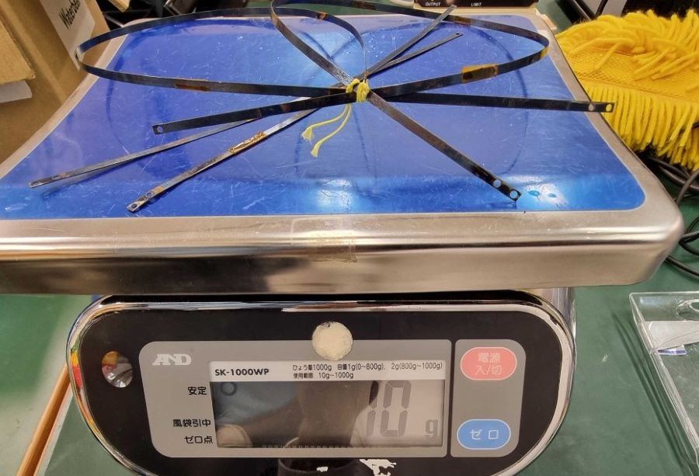

**Figure 3.1-2 Test configuration of wire strength test**

* 1. **Strength Test for Flight Equivalent Wire (ultimate load)**

1. **Creep characteristics**

To accelerate the test time, in the creep test, the load (1,810 gf) which is larger than the design load (378gf), is applied to the wire. The target wire which is the same lot as the flight model is pulled with the load (1,810 gf) to pass creep phase. Note that the load is considered the case of one wire missing. The length of the wire is measured periodically, and the length is verified not to be changed after sufficient test duration, since the creep characteristics has 1st creep phase and 2nd creep phase.

Test configuration is shown in Figure 3.2-1.

1. **Strength test on the wire that restrains the antenna**

The total mass of the antenna element is 10g (See Figure 3.1-2). Therefore, the load applied to the antenna by the launch environment (9G) is 90gf. Since the antenna deployment force is 288gf, the design load is 378gf. After creeping, the target wire is pulled with the load greater than the ultimate load which multiplies the design load* (=378 gf) by 2.0 as safety margin. Note that the load is considered the case of one wire missing. And the wire is verified not to be broken nor damaged and the knot has no looseness. Test configuration is shown in Figure 3.2-1.

Test results are shown in Figure 4.1-1 and Figure 4.1-2. There were no breaks, damage, or loose knots on the target wire.

*: Combined load of restraining load for the deployment and the launch load (9G). The restraining force must be considered the case of one wire missing.

Same lot of flight wire

Test weight

1810[gf] for creep test

* 798 [gf] for strength test

Same knotting method as flight

**Figure 3.2-1 Test configuration of wire strength test**

* 1. **Proof Test for Flight Wire**

1. **Creep characteristics**

To accelerate the test time, in the creep test, the load (1,810 gf) which is larger than the design load (378gf), is applied to the wire. The target wire which is the same lot as the flight model is pulled with the load (1,810 gf) to pass creep phase. Note that the load is considered the case of one wire missing. The length of the wire is measured periodically, and the length is verified not to be changed after sufficient test duration, since the creep characteristics has 1st creep phase and 2nd creep phase.

Test configuration is shown in Figure 3.3-1.

*Design load: Combined load of restraining load for the deployment and the launch load (9G). The restraining force must be considered the case of one wire missing.

Note that this test can be conducted concurrently with the test of 3.1(1).

1. **Proof test on the wire that restrains the antenna**

After creeping, the target wire is pulled with the load greater than the proof load which multiplies the design load* (=378 gf) by 1.2 as safety margin. Note that the load is considered the case of one wire missing. And the wire is verified not to be broken nor damaged and the knot has no looseness.

Test configuration is shown in Figure 3.3-1.

Test results are shown in Figure 4.1-1 and Figure 4.2-1. There were no breaks, damage, or loose knots on the target wire.

*: Combined load of restraining load for the deployment and the launch load (9G). The restraining force must be considered the case of one wire missing.

Flight wire

Test weight

* 1810 [gf] for creep test
* 479 [gf] for proof test

Same knotting method as flight

**Figure 3.3-1 Test configuration of wire proof test**

# **Test Results**

Date of test：2022/01/29

Place of test：Center for Nanosatellite Testing (CeNT)

Laboratory of Lean Satellite Enterprises and In-Orbit Experiments

Kyushu Institute of Technology

1-1, Sensui, Tobata, Kitakyushu, 804-8550 Fukuoka, Japan

**Table 4-1 Test Objectives**

|  |  |  |  |
| --- | --- | --- | --- |
|  | Part Name | Part Number | Quantity |
| 1 | PE line | BIRDS-5 wire | 4 |

## **Strength test**

1. Creep Characteristics

The test duration was 121 days which is sufficient time to pass creep phase, and the length was not changed at the end phase of this test. After load was applied, the wire was not broken nor damaged, and the knot had no looseness.

Figure 4.1-1 shows the test result. After load was applied, the wire was not broken nor damaged, and the knot had no looseness.

1. Strength Test

Figure 4.1-2 shows the test result. After load was applied, the wire was not broken nor damaged, and the knot had no looseness.

**Figure 4.1-1 Test result of creep characteristics (load: 1810 [gf])**

**Figure 4.1-2 Strength Test Result (load: 798 [gf])**

## **Proof test**

1. Creep Characteristics

The test duration was 121 days which is sufficient time to pass creep phase, and the length was not changed at the end phase of this test. After load was applied, the wire was not broken nor damaged, and the knot had no looseness.

Figure 4.1-1 shows the test result. After load was applied, the wire was not broken nor damaged, and the knot had no looseness.

1. Proof Test

Figure 4.2-1 shows the test result. After load was applied, the wire was not broken nor damaged, and the knot had no looseness.

**Figure 4.2-1 Proof Test Results (load: 479 [gf])**

# **Conclusion**

The result of the wire strength test conforms to the requirement.